**INTRODUCTION TO DATA MANAGEMENT**

**PROJECT REPORT**

(Project Semester January-April 2025)

***Sales Metrics Dashboard***

Submitted by

P. Rama Sai Jahnavi

12308734

B-TECH Computer Science and Engineering

INT217

Under the Guidance of

**Dr. Mrinalini Rana (UID : 22138)**

**Discipline of CSE/IT**

**Lovely School of Computer Science**

**Lovely Professional University, Phagwara**

**CERTIFICATE**

This is to certify that P. Rama Sai Jahnavi bearing Registration no. 12308734 has completed INT217 project titled, **“Sales Metrics Dashboard”** under my guidance and supervision. To the best of my knowledge, the present work is the result of her original development, effort and study.

**Signature and Name of the Supervisor**

**Dr. Mrinalini Rana (UID: 22138)**

**School of Computer Science**

Lovely Professional University

Phagwara, Punjab.

Date: 04-04-2025

**DECLARATION**

I, P. Rama Sai Jahnavi, student of B-Tech CSE under CSE/IT Discipline at, Lovely Professional University, Punjab, hereby declare that all the information furnished in this project report is based on my own intensive work and is genuine.

Date: 04-04-2025 P. Jahnavi

Registration No. 12308734 P. Rama Sai Jahnavi

**ACKNOWLEDGEMENT**

I would like to express my sincere gratitude to my project guide, **Dr. Mrinali Rana Mam**, for their invaluable support, motivation, and expert guidance throughout the course of this project. Their constructive feedback and continuous encouragement have been instrumental in shaping the direction and outcome of this work.

I am deeply thankful to the faculty of the **Computer Science Department, Lovely Professional University**, for providing me with a solid foundation in data analysis and for encouraging an analytical approach toward solving real-world problems. Their teachings and the academic environment they fostered have played a key role in the successful completion of this Data Science Minor Project.

I also extend my heartfelt thanks to my classmates and friends who supported me with their valuable inputs, constant motivation, and helpful discussions that enriched my understanding during the project development process.

I owe special thanks to my family, whose unwavering belief in my potential and consistent moral support gave me the strength and determination to complete this work with confidence and commitment.

Finally, I express my appreciation to all the authors, online communities, and platforms that provided valuable resources and tutorials on Excel dashboards and data visualization techniques, which proved extremely helpful during the project.

This project would not have been possible without the collective support and contributions of everyone mentioned above.

**INTRODUCTION**

In the modern business environment, data is one of the most valuable assets. Organizations rely on accurate data analysis to assess performance, identify trends, and make strategic decisions. Sales performance is a critical component of business success, as it directly impacts revenue generation, customer satisfaction, and operational efficiency. This project, titled **"Sales Performance Metrics Dashboard Using Microsoft Excel,"** aims to provide a comprehensive analysis of sales data by leveraging Excel as a powerful analytical and visualization tool.

The objective of this project is to transform raw sales data into insightful visual representations that can guide stakeholders in making informed decisions. While many advanced tools like Power BI, Tableau, and Python-based frameworks exist for data analysis, Microsoft Excel remains one of the most accessible and widely used platforms due to its simplicity, familiarity, and robust features. By utilizing Excel’s capabilities such as pivot tables, charts, slicers, and conditional formatting, the project delivers an interactive and user-friendly dashboard that highlights key sales metrics.

The sales data used in this project is a simulated dataset that mimics real-world business scenarios. It includes information on consultants, sales teams, training models, advertising channels, call status, enrollment statistics, and area-wise sales performance. The dashboard is built to analyze multiple dimensions of this data—tracking total earnings, identifying top performers, evaluating advertising effectiveness, and visualizing monthly trends. These insights enable businesses to understand which areas are excelling and which need improvement.

One of the key benefits of this project is that it bridges the gap between data collection and business intelligence. Often, data is underutilized due to lack of tools or expertise. This dashboard empowers users to explore and interpret sales data even without a background in programming or data science. It is especially helpful for small and medium-sized businesses that may not have access to high-end BI tools but still need to perform essential data analysis.

The report is structured to cover all essential aspects of the project. It begins with a description of the dataset, followed by preprocessing steps that were crucial in preparing the data for analysis. These steps include cleaning data, standardizing formats, handling missing or irrelevant entries, and deriving additional metrics for temporal and categorical analysis. Once the data was refined, the dashboard was developed to focus on specific objectives like identifying top consultants, comparing earnings across months, and analyzing the distribution of paid and unpaid calls.

The analysis section of the report discusses each objective in detail, presenting general descriptions, specific requirements, analysis results, and the visualizations used. This modular approach ensures clarity and ease of understanding for each metric being analyzed. The dashboard includes bar graphs, pie charts, line graphs, and dynamic slicers, all of which contribute to a comprehensive visual representation of sales data.

This project also demonstrates the importance of visualization in data science. While numerical data and statistical summaries are informative, visualizations can often communicate insights more effectively and intuitively. A well-designed dashboard makes it easier to compare data points, recognize patterns, and detect anomalies.

In addition to offering practical insights, the project serves as an educational experience. It showcases how traditional tools like Excel can be creatively employed for modern data science applications. It builds analytical thinking, attention to detail, and the ability to communicate results through visuals—all essential skills for aspiring data professionals.

Ultimately, the **Sales Performance Metrics Dashboard Using Microsoft Excel** exemplifies the value of turning data into actionable insights. By the end of the project, users are equipped with a fully functional tool that supports strategic decision-making, enhances performance monitoring, and contributes to overall business intelligence.

**SOURCE OF DATASET**

The dataset utilized for this project was derived from **simulated organizational sales data**, created to reflect realistic business scenarios. It includes comprehensive details such as:

* Consultant and sales team performance
* Paid and unpaid call records
* Area codes and regional data
* Advertising channels and associated spend
* Training models and their respective fees
* Enrolment data across various training levels
* Call durations, dates, and engagement information

This dataset was designed to support multi-dimensional analysis of sales performance metrics. Although fictional in origin, the structure and variables mirror actual business operations, making it suitable for data visualization, trend analysis, and performance benchmarking in a controlled academic setting.

**DATASET PREPROCESSING**

To ensure accurate and meaningful analysis, the dataset underwent a series of preprocessing steps before visualization:

* **Data Cleaning**: Removed duplicate, missing, and irrelevant entries to improve data integrity.
* **Standardization**: Unified data formats, especially for dates, currencies, and categorical fields like status and training levels.
* **Date and Time Processing**: Extracted month names and converted call durations into consistent numeric formats to enable monthly and duration-based analysis.
* **Derived Columns**: Added calculated fields such as total earnings, average call durations, and enrolment counts for deeper insights.
* **Categorization**: Grouped data based on sales teams, consultants, area codes, and advertising channels for segment-wise analysis.
* **Validation**: Cross-checked numerical columns (e.g., Paid Fees, Enrolled Courses) to ensure logical consistency and correctness.

These preprocessing steps helped transform raw sales data into a structured and analysis-ready format suitable for building an interactive dashboard.

**ANALYSIS OF DATASET**

**Objective 1: Total Earnings**

1. **General Description**

This objective focuses on calculating the Total Earnings generated from sales. It reflects the overall revenue by summing up the product of unit prices and quantities sold. This is crucial for assessing the company’s profitability and financial performance over time.

1. **Specific Requirements**

To achieve this objective, the following data points are necessary:

* Unit Price (price of one unit of a product)
* Order Quantity (number of units sold per order)

1. **Analysis Results**

The Total Earning from sales is **EGP 15,99,00,00,000.**

|  |  |  |
| --- | --- | --- |
|  |  |  |
|  | **Table 1: Total Earnings** |  |
|  |  |  |
|  | **Sum of Paid Fees** |  |
|  | EGP 15,99,00,00,000 |  |
|  |  |  |

1. 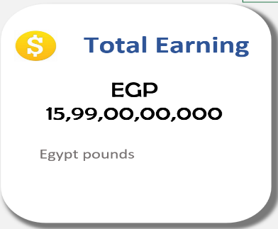**Visualization**

**Objective 2: Total Paid and Unpaid Status**

* 1. **General Description**

This objective tracks the payment status of orders — identifying how many have been paid versus how many remain unpaid. It’s essential for understanding cash flow, customer payment behaviour, and outstanding receivables.

* 1. **Specific Requirements**

To achieve this, you need:

* A column (likely named something like Payment Status, Status, or similar)
* Entries categorized as "Paid" and "Unpaid"
  1. **Analysis Results**

From the dataset:

* Paid Orders: 311
* Unpaid Orders: 926
  1. 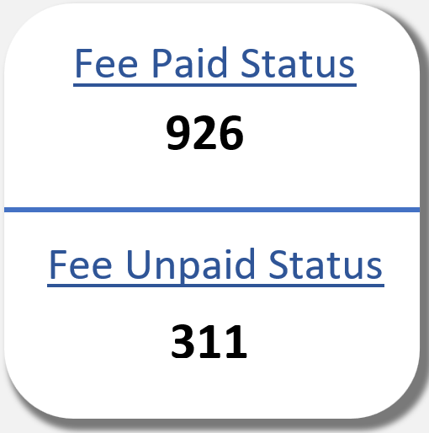**Visualization**

|  |  |  |  |
| --- | --- | --- | --- |
|  |  |  |  |
|  | **Table 2: Total Paid and Unpaid Status** | |  |
|  |  |  |  |
|  | **Row Labels** | **Count of Fees Status** |  |
|  | Not Paid | 311 |  |
|  | Paid | 926 |  |
|  | **Grand Total** | **1237** |  |
|  |  |  |  |

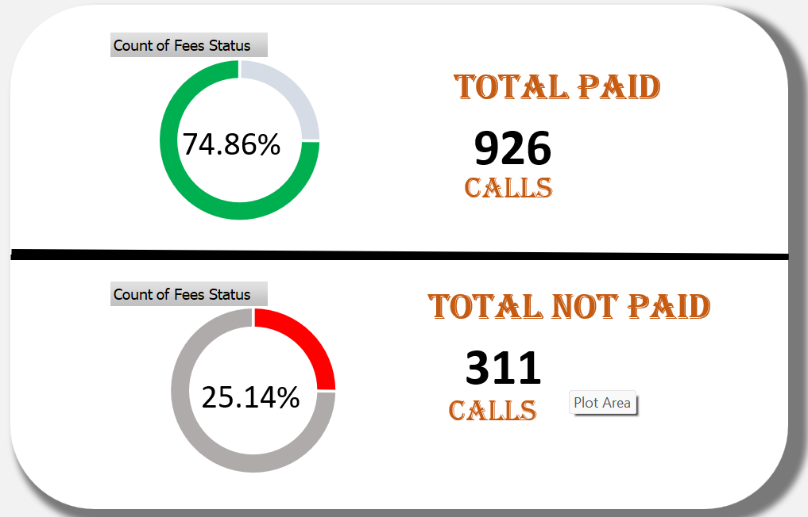

**Objective 3: Top 5 Consultant Sales Revenue**

* 1. **General Description**

This objective identifies the top-performing sales consultants based on their total revenue generated. This is key for recognizing top talent, rewarding performance, and planning future sales strategies.

* 1. **Specific Requirements**

To achieve this, you need:

* A column with Consultant Names (or IDs)
* Associated Order Quantity and Unit Price for each sale
* Calculation of Sales Revenue per consultant:

Revenue per Order = Unit Price × Order Quantity

|  |  |
| --- | --- |
| Mohmed | EGP 1,72,70,00,000 |
| Rony | EGP 1,63,80,00,000 |
| Hany | EGP 1,53,40,00,000 |
| Dary | EGP 1,36,00,00,000 |
| Kisho | EGP 1,28,80,00,000 |

* 1. **Analysis Results**

**Top 5 Consultant Sales Revenue:**

* 1. 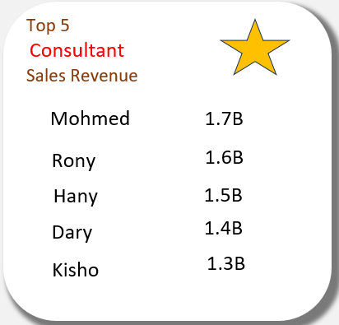**Visualization**

|  |  |  |  |
| --- | --- | --- | --- |
|  |  |  |  |
|  | **Table 3: Top 5 Consultant Sales Revenue** | |  |
|  |  |  |  |
|  | **Row Labels** | **Sum of Paid Fees** |  |
|  | Mohmed | EGP 1,72,70,00,000 |  |
|  | Rony | EGP 1,63,80,00,000 |  |
|  | Hany | EGP 1,53,40,00,000 |  |
|  | Dary | EGP 1,36,00,00,000 |  |
|  | Kisho | EGP 1,28,80,00,000 |  |
|  | Reham | EGP 1,24,30,00,000 |  |
|  | Khalil | EGP 1,17,70,00,000 |  |
|  | Sahar | EGP 1,06,60,00,000 |  |
|  | John | EGP 1,02,90,00,000 |  |
|  | Hisham | EGP 99,50,00,000 |  |
|  | Dina | EGP 83,20,00,000 |  |
|  | Ahmed | EGP 65,00,00,000 |  |
|  | Kenza | EGP 41,10,00,000 |  |
|  | Adam | EGP 37,90,00,000 |  |
|  | Habib | EGP 33,20,00,000 |  |
|  | Jood | EGP 32,90,00,000 |  |
|  | **Grand Total** | **EGP 15,99,00,00,000** |  |
|  |  |  |  |

**Objective 4: Total Earnings by month's**

1. **General Description**

This objective focuses on tracking how Total Earnings vary across months, helping analyze sales performance trends over time. It's essential for understanding seasonality, planning marketing campaigns, and forecasting revenue.

1. **Specific Requirements**

To compute Total Earnings by Month, you’ll need:

* A column with Order Date (or similar date field)
* Unit Price and Order Quantity for each sale
* Earnings per Order = Unit Price × Order Quantity
* Extract Month from Order Date

1. **Analysis Results**

|  |  |  |  |  |  |  |
| --- | --- | --- | --- | --- | --- | --- |
|  |  |  |  |  |  |  |
|  | **Table 4: Total Earnings by month's** | |  |  |  |  |
|  |  |  |  |  |  |  |
|  | **Row Labels** | **Sum of Paid Fees** |  |  |  |  |
|  | Jan | 984.0M |  |  |  |  |
|  | Feb | 1.0B |  |  |  |  |
|  | Mar | 116.0M |  |  |  |  |
|  | Apr | 538.0M |  |  |  |  |
|  | May | 1.2B |  |  |  |  |
|  | Jun | 512.0M |  |  |  |  |
|  | Jul | 442.0M |  |  |  |  |
|  | Aug | 1.2B |  |  |  |  |
|  | Sep | 2.2B |  |  |  |  |
|  | Oct | 3.8B |  |  |  |  |
|  | Nov | 2.8B |  |  |  |  |
|  | Dec | 1.2B |  |  |  |  |
|  | **Grand Total** | **16.0B** |  |  |  |  |
|  |  |  |  |  |  |  |
|  |  |  |  |  |  |  |

Maximum, minimum, Average Earnings by Month

1. **Visualization**

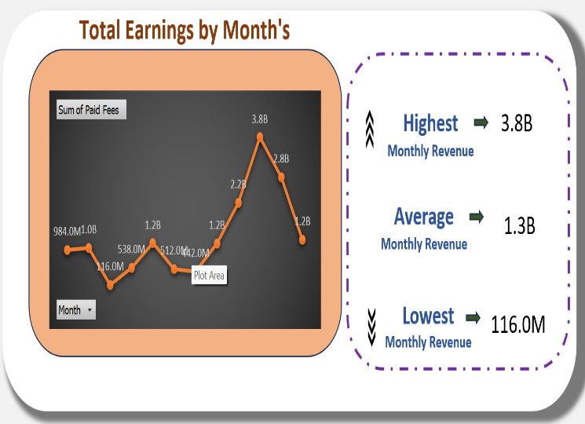

**Objective 5: Total Enrolled Courses**

1. **General Description**

This objective identifies how many courses have been enrolled in total, which helps measure customer engagement, course popularity, and overall training or learning success.

1. **Specific Requirements**

To calculate Total Enrolled Courses, your data needs:

* A column that lists Course Names or Course IDs
* A field that indicates Enrolment Status, or each row itself represents an enrolment

1. **Analysis Results**

|  |  |  |  |  |  |
| --- | --- | --- | --- | --- | --- |
|  |  |  |  |  |  |
|  | **Table 6: Total Enrolled Courses** | |  |  |  |
|  |  |  |  |  |  |
|  | **Row Labels** | **Sum of Enrolled Courses** |  | **Average of Enrolled Courses** |  |
|  | Jan | 170 |  | 2.137 |  |
|  | Feb | 162 |  |  |  |
|  | Mar | 12 |  |  |  |
|  | Apr | 102 |  |  |  |
|  | May | 174 |  |  |  |
|  | Jun | 96 |  | **Sum of Enrolled Courses** |  |
|  | Jul | 60 |  | 2,643.00 |  |
|  | Aug | 189 |  |  |  |
|  | Sep | 387 |  |  |  |
|  | Oct | 617 |  |  |  |
|  | Nov | 468 |  |  |  |
|  | Dec | 206 |  |  |  |
|  | **Grand Total** | **2,643** |  |  |  |
|  |  |  |  |  |  |
|  |  |  |  |  |  |

1. **Visualization**

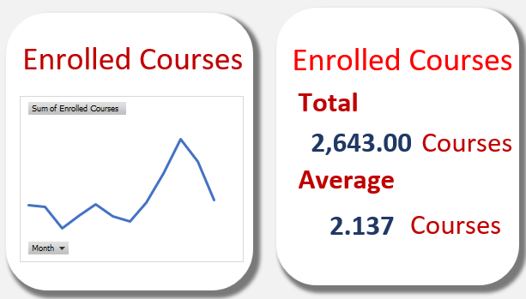

**Objective 6: Counting of Area Code**

* 1. **General Description**

This objective involves counting the number of entries (such as customers, orders, or transactions) grouped by Area Code. It helps understand regional distribution, sales reach, and geographical demand.

* 1. **Specific Requirements**
* A column named something like Area Code, Region Code, or similar.
* Each row should correspond to an order, customer, or transaction.
* You’ll count how many times each unique Area Code appears.
  1. 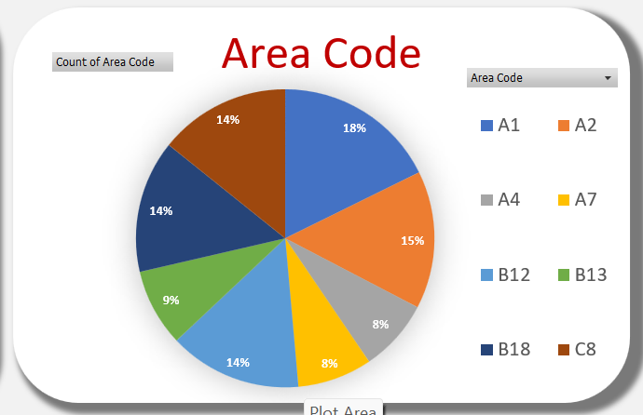**Analysis Results & Visualization**

|  |  |
| --- | --- |
| **Row Labels** | **Count of Area Code** |
| A1 | 219 |
| A2 | 185 |
| A4 | 97 |
| A7 | 100 |
| B12 | 178 |
| B13 | 104 |
| B18 | 178 |
| C8 | 176 |
| **Grand Total** | **1237** |

**Objective 7: Counting of Area Code**

1. **General Description**

This objective aims to list and analyse different training models or modules that have been offered or enrolled in. It helps track the types of skills or topics delivered, how popular each training model is, and their role in user upskilling or organizational development.

1. **Specific Requirements**

To work on this objective, your Excel file should include:

* A column labelled something like Training Model, Course Model, Program Name, or Module Name
* Each row representing a training enrolment or offering
* Count how many times each model appears (enrolments per model)
* Analyse trends: e.g., which model is preferred in certain regions, or which ones generate more revenue

1. 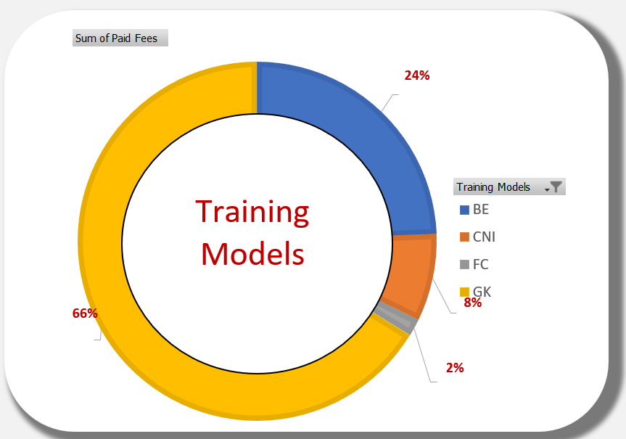**Analysis Results & Visualization**

|  |  |
| --- | --- |
| **Table 8: Training Models** | |
|  |  |
| **Row Labels** | **Sum of Paid Fees** |
| BE | 3.9B |
| CNI | 1.3B |
| FC | 247.0M |
| GK | 10.6B |
| **Grand Total** | **16.0B** |

**Objective 8: Training Levels by Sales Team**

1. **General Description**

This objective focuses on identifying and analyzing the training levels completed by members of the sales team. It helps assess how well-trained the team is, track individual or group progress, and ensure skill development aligns with company goals.

1. **Specific Requirements**

To analyse Training Levels by Sales Team, you need:

* A column with Sales Team member names or IDs
* A column with Training Level

**Pivot Table**:

* Rows: Sales Team Members
* Columns: Training Levels
* Values: Count of Trainings

1. 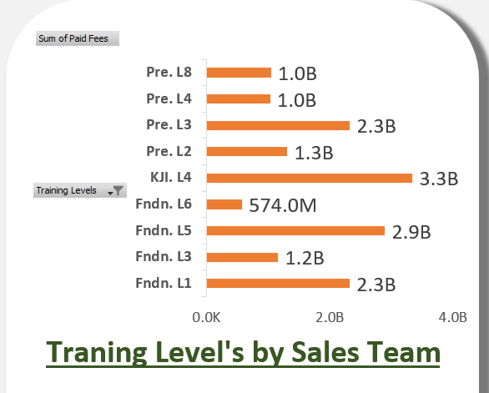**Analysis Results & Visualization**

|  |  |
| --- | --- |
| **Table 9: Training Levels by Sales Team** | |
|  |  |
| **Row Labels** | **Sum of Paid Fees** |
| Fndn. L1 | 2.3B |
| Fndn. L3 | 1.2B |
| Fndn. L5 | 2.9B |
| Fndn. L6 | 574.0M |
| KJI. L4 | 3.3B |
| Pre. L2 | 1.3B |
| Pre. L3 | 2.3B |
| Pre. L4 | 1.0B |
| Pre. L8 | 1.0B |
| **Grand Total** | **16.0B** |

**Objective 9: Enrolled courses on Training Levels**

1. **General Description**

This objective analyses how courses are distributed across different training levels — such as Beginner, Intermediate, and Advanced. It helps you understand the depth and difficulty of course offerings, and whether learners are progressing through levels effectively.

1. **Specific Requirements**

To analyse this, your dataset needs:

* A column for Course Name or Course ID
* A column for Training Level
* Each row representing a course enrolment

**Pivot Table**:

* Rows: Training Level
* Columns: Course Name (optional)
* Values: Count of Enrolments

1. 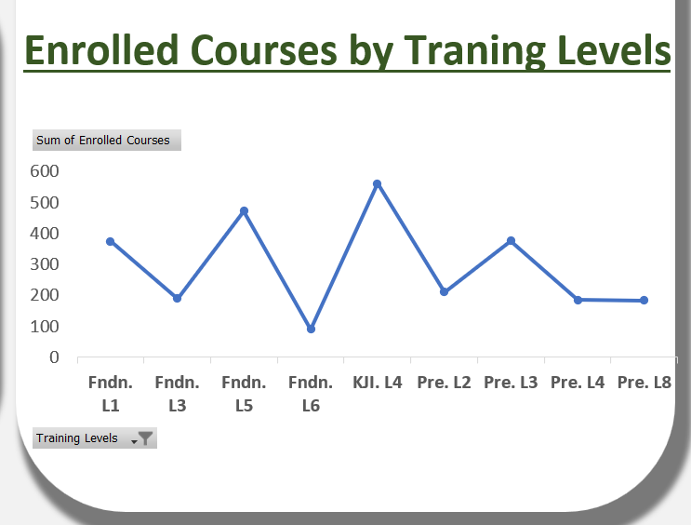**Analysis Results & Visualization**

|  |  |
| --- | --- |
| **Table 10: Enrolled courses on Training Levels** | |
|  |  |
| **Row Labels** | **Sum of Enrolled Courses** |
| Fndn. L1 | 374 |
| Fndn. L3 | 189 |
| Fndn. L5 | 472 |
| Fndn. L6 | 90 |
| KJI. L4 | 562 |
| Pre. L2 | 211 |
| Pre. L3 | 376 |
| Pre. L4 | 185 |
| Pre. L8 | 184 |
| **Grand Total** | **2,643** |

**Objective 10: Top 5 Training Level**

1. **General Description**

This objective identifies the Top 5 Training Levels based on the number of enrolments. It shows which levels are most in demand, helping organizations focus on the most impactful or popular training stages.

1. **Specific Requirements**

* A column for Training Level
* A row per enrolment

**Pivot Table**:

* Rows: Training Level
* Values: Count of Enrolments
* Sort: Descending by Count

1. 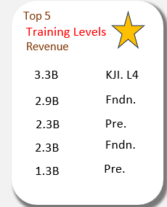**Analysis Results & Visualization**

|  |  |
| --- | --- |
| **Table 11: Top 5 Training Level** | |
|  |  |
| **Row Labels** | **Sum of Paid Fees** |
| KJI. L4 | 3.3B |
| Fndn. L5 | 2.9B |
| Pre. L3 | 2.3B |
| Fndn. L1 | 2.3B |
| Pre. L2 | 1.3B |
| **Grand Total** | **12.2B** |

**Objective 11: Average Paid Calls Duration By Months**

1. **General Description**

This objective calculates the average duration of paid calls for each month. It helps evaluate customer engagement, service delivery, and how usage patterns change over time.

1. **Specific Requirements**

To perform this analysis, your Excel file should include:

* A column for Call Duration (in minutes or seconds)
* A column for Call Status (with values like "Paid" or "Unpaid")
* A column with Call Date or Order Date

Use Pivot Table:

* Filters: Call Status = "Paid"
* Rows: Month (from Call Date)
* Values: Average of Call Duration

1. **Analysis Results**

|  |  |
| --- | --- |
| **Table 12: Average Paid Calls Duration by Months** | |
|  |  |
| **Row Labels** | **Average of Average call duration** |
| Jan | 04:27 |
| Feb | 04:23 |
| Mar | 05:02 |
| Apr | 04:37 |
| May | 03:56 |
| Jun | 03:42 |
| Jul | 04:44 |
| Aug | 04:29 |
| Sep | 04:38 |
| Oct | 04:38 |
| Nov | 04:35 |
| Dec | 04:38 |
| **Grand Total** | **04:32** |

|  |  |
| --- | --- |
| Average | 04:29 |
| Maximum | 05:02 |
| Minimum | 03:42 |

1. **Visualization**

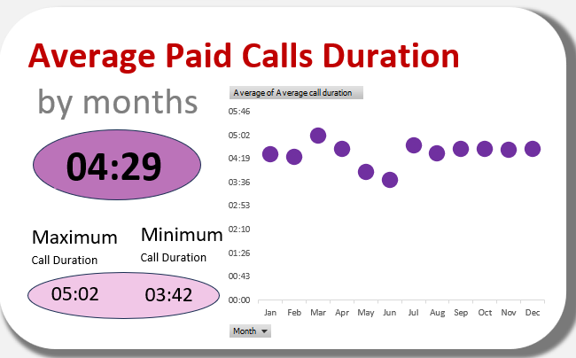

**Objective 12: Total Sales by Sales Teams**

* 1. **General Description**

This objective analyses the total sales generated by each sales team member. It's useful for performance evaluation, incentive planning, and identifying top performers or training needs.

* 1. **Specific Requirements**
* A column for Sales Team Member Name or ID
* A column for Sales Amount

Use a Pivot Table:

* Rows: Sales Team Members
* Values: Sum of Sales Amount
  1. **Analysis Results**

|  |  |  |
| --- | --- | --- |
| **Tabel 13: Total Sales by Sales Teams** | | |
|  |  |  |
| **Row Labels** | **Sum of Paid Fees** | **Sum of Paid Fees2** |
| Abdullah | 2.6B | 2.6B |
| Ahmed | 2.8B | 2.8B |
| Mohammed | 5.4B | 5.4B |
| Salah | 5.3B | 5.3B |
| **Grand Total** | **16.0B** | **16.0B** |

|  |  |
| --- | --- |
| **Row Labels** | **Sum of Paid Fees** |
| Mohammed | 5.4B |
| Salah | 5.3B |
| Ahmed | 2.8B |
| Abdullah | 2.6B |
| **Grand Total** | **16.0B** |

* 1. **Visualization**

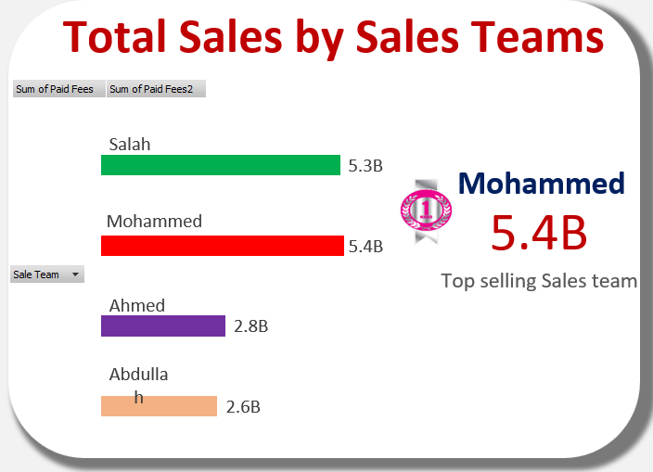

**Objective 13: Consultant by total sales**

* 1. **General Description**

This objective focuses on determining the total sales generated by each consultant. It helps evaluate individual consultant performance, track contribution to revenue, and inform incentives or recognition programs.

* 1. **Specific Requirements**

To analyse this, your dataset should include:

* A column for Consultant Name or ID
* A column for Sales Amount (or data to calculate it, such as price × quantity)

Use a Pivot Table:

* Rows: Consultant Name
* Values: Sum of Sales Amount
  1. 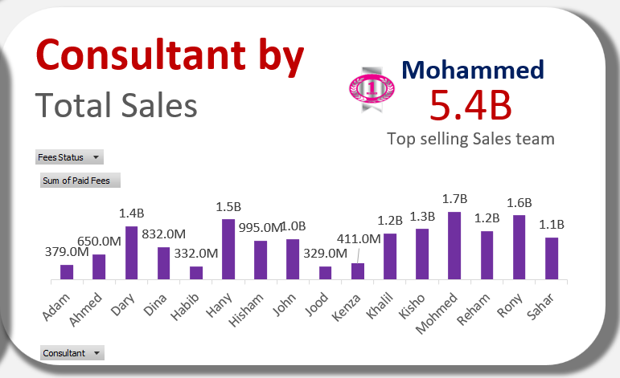**Analysis Results & Visualization**

|  |  |
| --- | --- |
| **Table 14: Consultant by total sales** | |
|  |  |
| **Row Labels** | **Sum of Paid Fees** |
| Adam | 379.0M |
| Ahmed | 650.0M |
| Dary | 1.4B |
| Dina | 832.0M |
| Habib | 332.0M |
| Hany | 1.5B |
| Hisham | 995.0M |
| John | 1.0B |
| Jood | 329.0M |
| Kenza | 411.0M |
| Khalil | 1.2B |
| Kisho | 1.3B |
| Mohmed | 1.7B |
| Reham | 1.2B |
| Rony | 1.6B |
| Sahar | 1.1B |
| **Grand Total** | **16.0B** |

**Objective 14: Advertising channel**

* 1. **General Description**

This objective aims to analyse how customers discovered or were referred to the platform via various advertising channels. It helps assess marketing effectiveness, measure channel ROI, and guide future campaign strategies.

* 1. **Specific Requirements**
* A column named something like Advertising Channel, Referral Source, or Marketing Medium
* Optional: Sales, Leads, or Enrolments associated with each channel

Pivot Table:

* Rows: Advertising Channel
* Values: Count of Customers / Sum of Sales
  1. 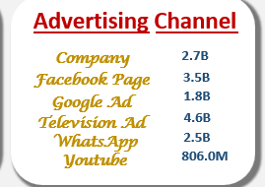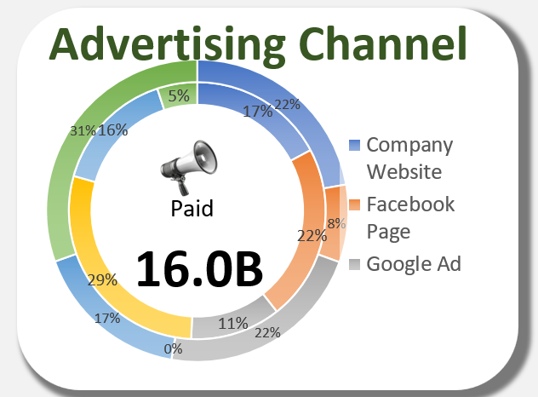**Analysis Results & Visualization**

|  |  |
| --- | --- |
| **Table 15: Advertising channel** | |
|  |  |
| Fees Status | (All) |
|  |  |
| **Row Labels** | **Sum of Paid Fees** |
| Company Website | 2.7B |
| Facebook Page | 3.5B |
| Google Ad | 1.8B |
| Television Ad | 4.6B |
| WhatsApp | 2.5B |
| Youtube Channel | 806.0M |
| **Grand Total** | **16.0B** |

|  |  |  |  |  |  |  |
| --- | --- | --- | --- | --- | --- | --- |
|  | Company Website | Facebook Page | Google Ad | Television Ad | WhatsApp | YouTube Channel |
| Actual | 2.7B | 3.5B | 1.8B | 4.6B | 2.5B | 806.0M |
| The difference to reach highest amount | 2.7B | 1.0B | 2.7B | 0.0K | 2.1B | 3.8B |

**Objective 15: Average call by month paid & unpaid**

1. **General Description**

This objective compares the average call durations each month, split into Paid and Unpaid calls. It helps in understanding engagement quality, service utilization trends, and potential billing performance month-over-month.

1. **Specific Requirements**

* A Call Date or Order Date column
* A Call Duration column (in minutes/seconds)
* A Call Status or Payment Status column (e.g., "Paid", "Unpaid")

1. 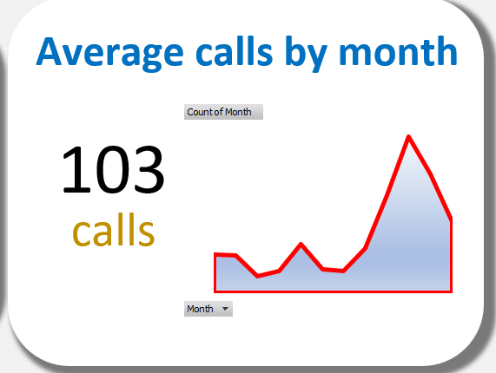**Analysis Results & Visualization**

|  |  |
| --- | --- |
| **Table 16: Average call by month paid & unpaid** | |
|  |  |
| **Row Labels** | **Count of Month** |
| Jan | 68 |
| Feb | 66 |
| Mar | 30 |
| Apr | 38 |
| May | 86 |
| Jun | 42 |
| Jul | 38 |
| Aug | 79 |
| Sep | 173 |
| Oct | 278 |
| Nov | 212 |
| Dec | 127 |
| **Grand Total** | **1237** |

**Objective 16: Training model fees by consultants**

1. **General Description**

This objective analyses the total fees generated from different training models handled by each consultant. It’s useful for understanding which consultant is contributing most through different training models, and how revenue is distributed.

1. **Specific Requirements**

Your dataset should include:

* A Consultant Name/ID column
* A Training Model column (e.g., Online, In-person, Hybrid, etc.)
* A Fee or Price column (amount charged per training)

1. **Analysis Results**

|  |  |  |  |  |  |
| --- | --- | --- | --- | --- | --- |
| **Table 17: Tranning model fees by consultants** | | | | | |
|  |  |  |  |  |  |
| **Sum of Paid Fees** | **Column Labels** |  |  |  |  |
| **Row Labels** | **FC** | **CNI** | **BE** | **GK** | **Grand Total** |
| Adam |  | 11.0M | 152.0M | EGP 21,60,00,000 | 379.0M |
| Ahmed |  | 100.0M | 114.0M | EGP 43,60,00,000 | 650.0M |
| Dary |  | 82.0M | 475.0M | EGP 80,30,00,000 | 1.4B |
| Dina |  | 60.0M | 247.0M | EGP 52,50,00,000 | 832.0M |
| Habib | 38.0M | 11.0M | 38.0M | EGP 24,50,00,000 | 332.0M |
| Hany | 76.0M | 162.0M | 589.0M | EGP 70,70,00,000 | 1.5B |
| Hisham |  | 20.0M | 171.0M | EGP 80,40,00,000 | 995.0M |
| John | 38.0M | 113.0M | 171.0M | EGP 70,70,00,000 | 1.0B |
| Jood |  | 22.0M | 95.0M | EGP 21,20,00,000 | 329.0M |
| Kenza |  | 100.0M | 171.0M | EGP 14,00,00,000 | 411.0M |
| Khalil | 19.0M | 122.0M | 114.0M | EGP 92,20,00,000 | 1.2B |
| Kisho |  | 97.0M | 247.0M | EGP 94,40,00,000 | 1.3B |
| Mohmed | 76.0M | 142.0M | 247.0M | EGP 1,26,20,00,000 | 1.7B |
| Reham |  | 115.0M | 228.0M | EGP 90,00,00,000 | 1.2B |
| Rony |  | 60.0M | 551.0M | EGP 1,02,70,00,000 | 1.6B |
| Sahar |  | 40.0M | 285.0M | EGP 74,10,00,000 | 1.1B |
| **Grand Total** | **247.0M** | **1.3B** | **3.9B** | **EGP 10,59,10,00,000** | **16.0B** |

1. **Visualization**

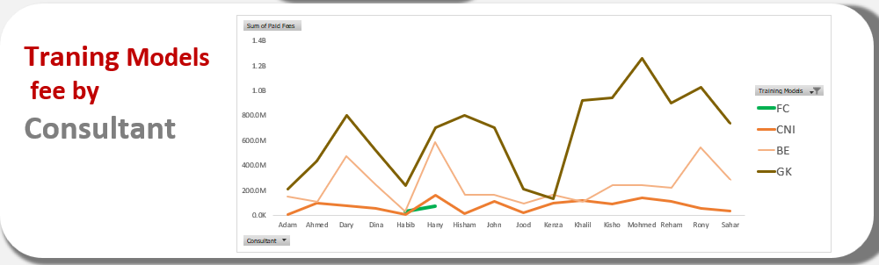

**Objective 17: Training models fees by sales team**

1. **General Description**

This objective analyses the fees generated from different training models, grouped by Sales Team members. It helps measure the revenue contribution of each sales team member based on the training types they’re responsible for selling or promoting.

1. **Specific Requirements**

Your dataset should include:

* Sales Team Member Name/ID
* Training Model Type (e.g., Online, In-person, Hybrid)
* Training Fees or total amount charged per model

1. **Analysis Results**

|  |  |  |  |  |  |
| --- | --- | --- | --- | --- | --- |
| **Table 18: Traning models fees by sales team** | | | | | |
|  |  |  |  |  |  |
| **Sum of Paid Fees** | **Column Labels** |  |  |  |  |
| **Row Labels** | **FC** | **CNI** | **BE** | **GK** | **Grand Total** |
| Abdullah |  | 146.0M | 513.0M | EGP 1,92,00,00,000 | 2.6B |
| Ahmed | 95.0M | 284.0M | 703.0M | EGP 1,66,90,00,000 | 2.8B |
| Mohammed | 114.0M | 410.0M | 1.3B | EGP 3,59,40,00,000 | 5.4B |
| Salah | 38.0M | 417.0M | 1.4B | EGP 3,40,80,00,000 | 5.3B |
| **Grand Total** | **247.0M** | **1.3B** | **3.9B** | **EGP 10,59,10,00,000** | **16.0B** |

1. 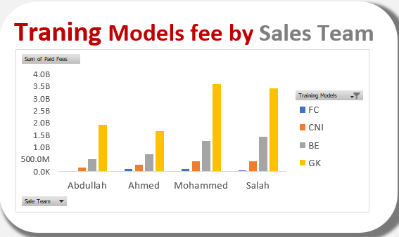**Visualization**

**Objective 18: Add Slicers for Filtered Analysis**

1. **General Description**

Slicers are visual filters that allow you to interactively filter data in pivot tables, pivot charts, or dashboards by categories such as:

* Months
* Sales Team
* Advertising Channel

They make the dashboard dynamic, letting you drill down into specific segments with a click.

1. **Specific Requirements**

Make sure your source dataset includes these columns:

* Month
* Sales Team Name
* Advertising Channel

You should also have:

* Pivot Tables/Charts already built using this data

**Insert Slicers:**

* Click anywhere in your Pivot Table
* Go to PivotTable Analyse → Insert Slicer
* Select:
  + Month
  + Sales Team
  + Advertising Channel

1. **Analysis Results & Visualization**

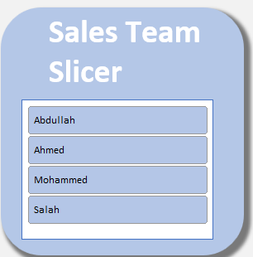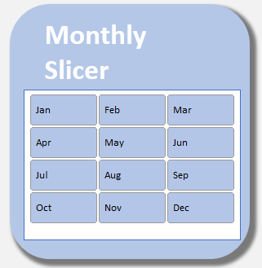**Monthly Slicer Sales Team Slicer**

**Advertising Channel Slicer**

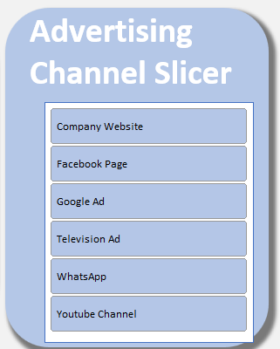

**CONCLUSION**

This project demonstrated how Microsoft Excel, despite being a conventional spreadsheet tool, can be leveraged effectively to conduct detailed data analysis and create an insightful, interactive sales dashboard. The dashboard not only displays a wide range of KPIs but also facilitates a deeper understanding of how each metric contributes to overall business success. Through the combination of pivot tables, slicers, data validation, conditional formatting, and dynamic charts, this dashboard offers an accessible and user-friendly way to perform business intelligence activities. Stakeholders can quickly identify performance trends, evaluate consultant and sales team efficiency, and assess the impact of advertising campaigns and training models. The project also emphasized the importance of clean data preprocessing and structuring, as these steps significantly impact the quality of the insights generated. With its capability to present data in both aggregated and granular formats, this Excel-based solution proves valuable for decision-makers who may not have access to more advanced tools like Power BI or Tableau. In conclusion, this project highlights the practicality of using Excel for real-world data science applications, especially in contexts where simplicity, cost-effectiveness, and ease of use are crucial. It bridges the gap between data collection and strategic action, ultimately contributing to more efficient sales management and improved organizational performance.

**FUTURE SCOPE**

Future improvements and expansions of this project may include:

* Integration with real-time data sources using Excel Power Query or APIs.
* Automation through VBA for real-time dashboard updates.
* Enhanced predictive modelling using machine learning integration.
* Expanding the dashboard to include customer satisfaction and retention metrics.

**REFERENCES**

* Microsoft Excel Documentation
* TutorialsPoint Excel Data Analysis Guides
* Project Mentor/Faculty Guidance
* Internal Training Materials and Simulated Dataset